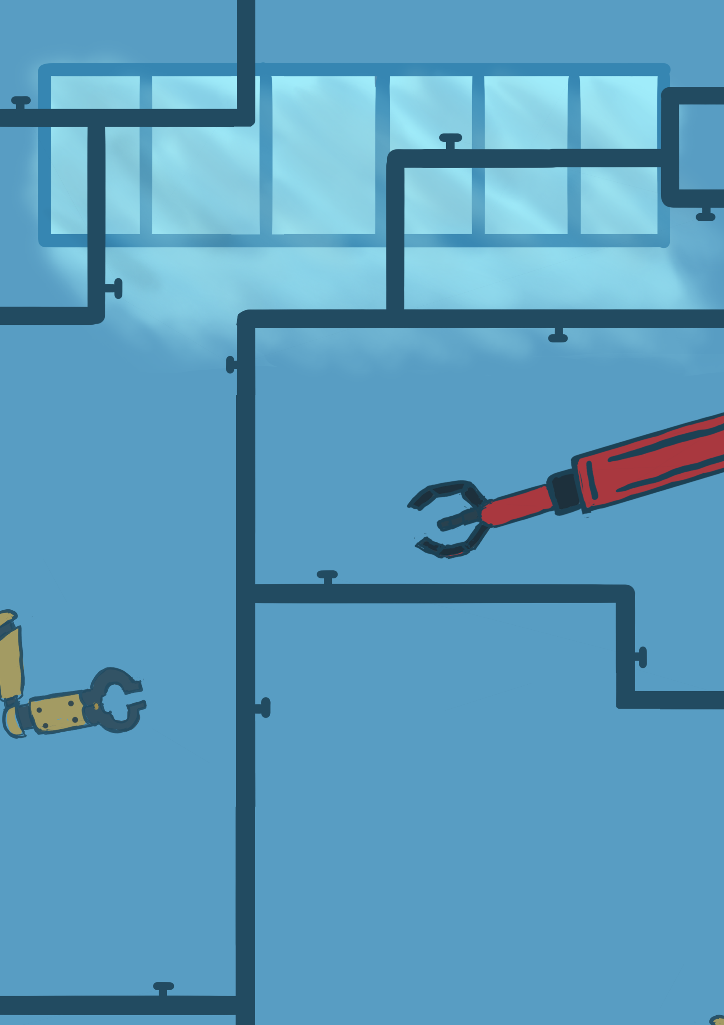

# **Do you want to make a robot?**

## **Chain Reaction**

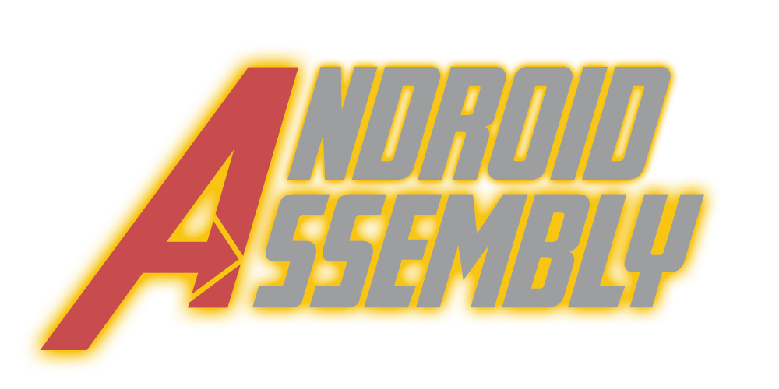

Team members:

Humam  
Tamara  
Rob  
Rick Oosthof – 421183  
Olivier  
Glyn

Grading Teachers:

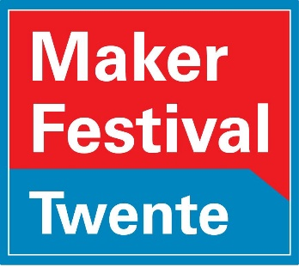Rene  
Remco?

Contents

Android Assembly Pictures 3

Merchandise 4

Play Test Feedback 5

Game Rules 6

Website 7

Trello board 8

Individual Work 10

Individual Work Humam: Sound Designer/General Artist 10

Individual Work Tamara – 2D Artist 11

Individual Work Rob – Scrum Master/ 3D Artist 12

Individual Work Rick – Web/Game designer 13

Individual Work Olivier – Chain Reaction Designer 14

Individual Work Glyn - Programmer 15

Teamwork reflection 16

# Android Assembly Pictures

# Merchandise

There’s a total of 4 merchandise options, 1 concept (the hoodie) and 3 that were concepted and then fully realized. (Stickers, poster and keyhangers)

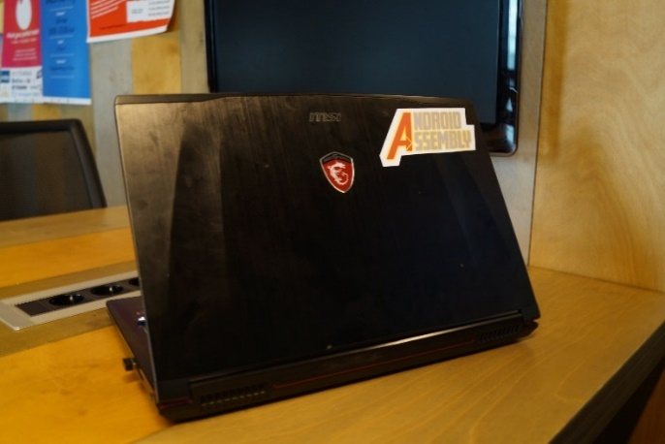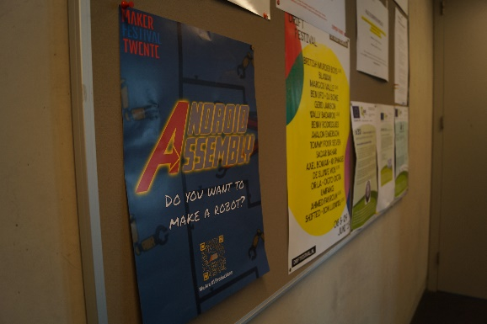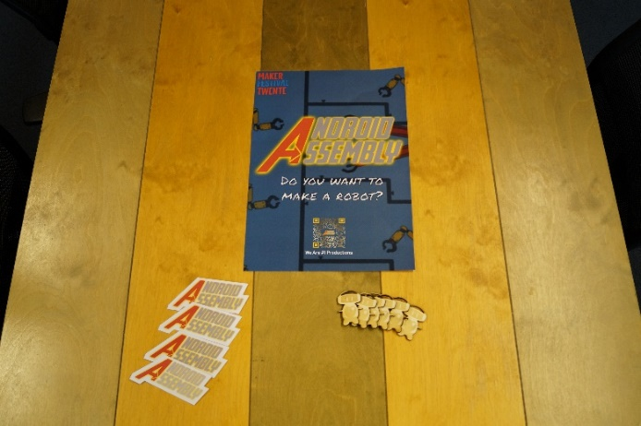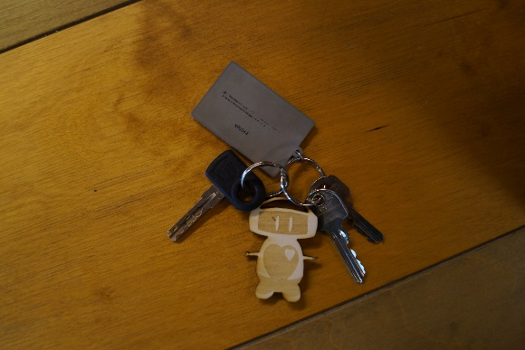

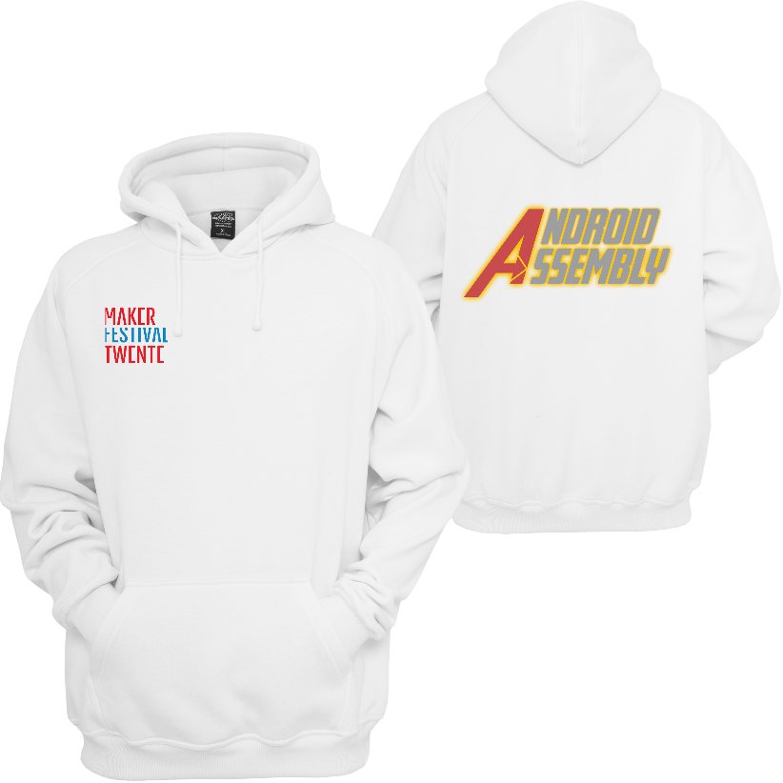

Play Test Feedback

**Processed Feedback**

**Positive points:**

The concept fits really well together between GXP and the mechanical bit.  
Concept fits really well with the target audience.  
The robot is a really fun idea.  
The art style is really nice and fits well with the children  
The theme overall makes sense  
The simplicity really fits the younger audience  
Aligns with metropolis well  
Magnet vs Fan is a really nice dichotomy  
Really cool robot design

**Discussion points:**

|  |  |
| --- | --- |
| Failure State | |
| Feedback for | Feedback against |
| Without failure state it can get boring really quickly(Especially older kids) | No failure state is nice for younger kids who have no experience with the mouse/anything |
| Without failure state the kids don’t learn | The game is too short for the kids to notice there’s no failure state anyway |

Arguments in group discussion: Objective isn’t to learn game but learn real-world knowledge. We target the younger audience overall. More of a toy than a game. It’s impossible to appeal to the entire range of 4-12 with one game, thus our focus is mostly on the young. Younger kids can still play.

Conclusion: After the arguments we voted on the option of a failure state(automatic reset) or no failure state at all. We voted and got 5-1, we talked to the last person who wanted it to be failable and presented our arguments and voting again after the result was 6-0 in favour.

|  |  |
| --- | --- |
| Art style too dim | |
| Feedback for | Feedback against |
| The art style has too much gray in it | Art style is really nice and simple and fits the children |
| The colours are very dim |  |

Arguments in group discussion: Assets are super colourful, so actually putting the assets on the backgrounds will make them pop and make this a non-argument. We changed the robot colour from gray to a brighter white to see how that looked.

Conclusion: We really liked the brighter white robot version so we changed to that, but kept the rest of the art unchanged.

|  |  |
| --- | --- |
| Longer chain reaction | |
| Feedback for | Feedback against |
| The chain reaction might be over so quickly they don’t notice it | People really liked the way it currently flows |

Arguments in group discussion: We disagree it’s too quick, with the max being 30 seconds we feel like our current ~20 seconds is already fine.  
Conclusion: No change.

# Game Rules

When the game starts, the robot will be in a safe position where none of the physics are affecting them. The player then has two options they can interact with in a small menu at the top of the screen: Fan and Magnet. The fan and magnet can be dragged and snapped into the dotted line **sockets**. 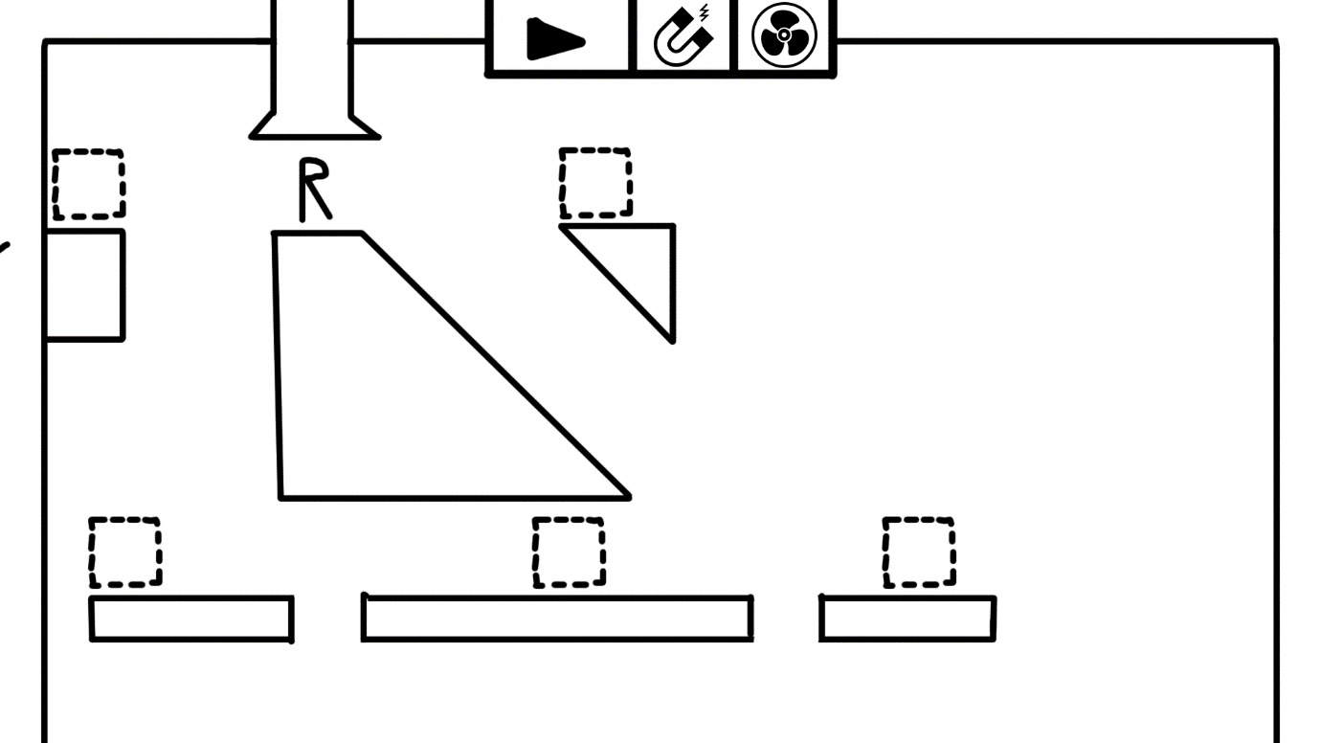

Objects will snap into the sockets, to make it clear where they’re supposed to go.  
The **fan** object pushes the player away from it and the **magnet** object pulls the player towards it. Usually, these objects will have a hole between the player and the object which the player will **fall** down, because **gravity should be stronger than the pull of the objects**. In case the player places a magnet and a fan opposite of each other, **the magnet should take priority over the fan.**There’s a third object which can’t be placed by the players, which is **conveyor belts** which move the player in a set direction. There is also the rotatory status, which means any object that can be placed can also be made to rotate in a certain direction.

The **camera** moves with the player as he goes to new “levels” each the height and width of the entire screen, but in reality it’s just one big level right under each other.

There’s a lot of fake choice in the levels, as no matter what you press you will get to the part but there’s different routes you can take depending on the magnet or the fan to make it seem to the player that their choices did impact the route the robot takes, it will however always lead to the part no matter what the player actually did. This is because the point of the game(toy) is to make players feel like they’re in control.

Website

Links:

<https://tinyurl.com/androidassembly> (For easy typing on mobile)

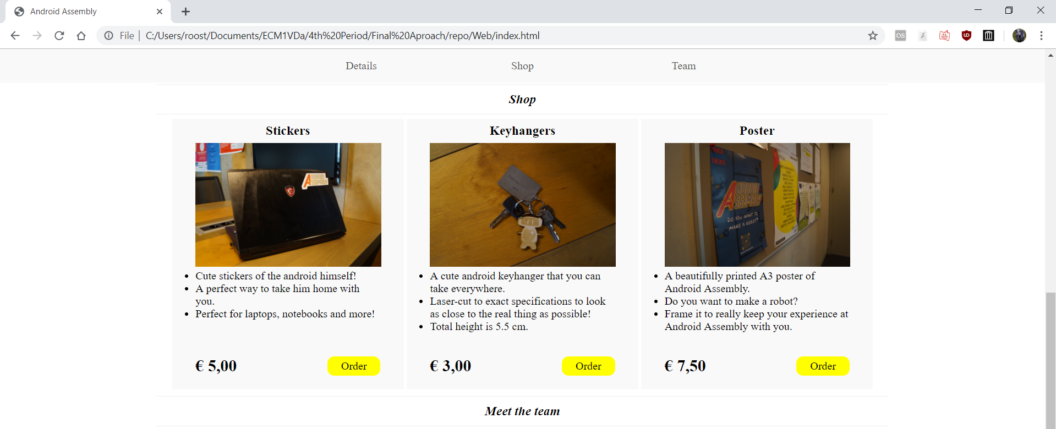

Android Assembly website is hosted via google drive and then drive to web. Written entirely in HTML5 and CSS it uses mostly custom div classes for the main structure with the exception of the nav bar. Both header and article are extensively used within the custom divs to clearly mark what content is being presented when. It’s a one page website with 3 sections. The structure of the document itself is divided as following: Landingpage, nav, description, shop, teamdisplay.

Landingpage is the image/video on the background and the logo, the first thing people see when they enter the site. I say image/video because we’ve tried both and there’s CSS and HTML for both. The first image is positioned relative in a div, with the logo in a new div and position absolute within it so it will always cover whatever content is within the landingpage. The nav is a sticky navigation bar that moves down with the user. The description is a few more pictures to look at as well as a nice description made to interest people for the chain reaction.

Shop is self explanatory, with the 3 items of merch we’ve worked out all on there. It uses a div for the shop windows which has a position-relative and a set height/width, whilst the price/buy button are in an position absolute div and position from the bottom. The <br> below the text in each shop window is actually for mobile, as the height on mobile is set by how long the text is(Since they’ll be under each other, they don’t need to all be the same height) so there needs to be at least one line of blank space for the price/buy button to go.

The teamdisplay works much the same as shop, just simpler as it is only one image and some text. On the bottom of the nav, the description and the shop are empty <h2> tags with the id of the page below them that have been hidden(In hindsight these should’ve probably been divs, but they were originally titles and I repurposed them). This is so that when you press the nav buttons and it takes you to the ID, the actual nav bar won’t cover the content you’re viewing by linking to slightly above the page instead.

# Trello board

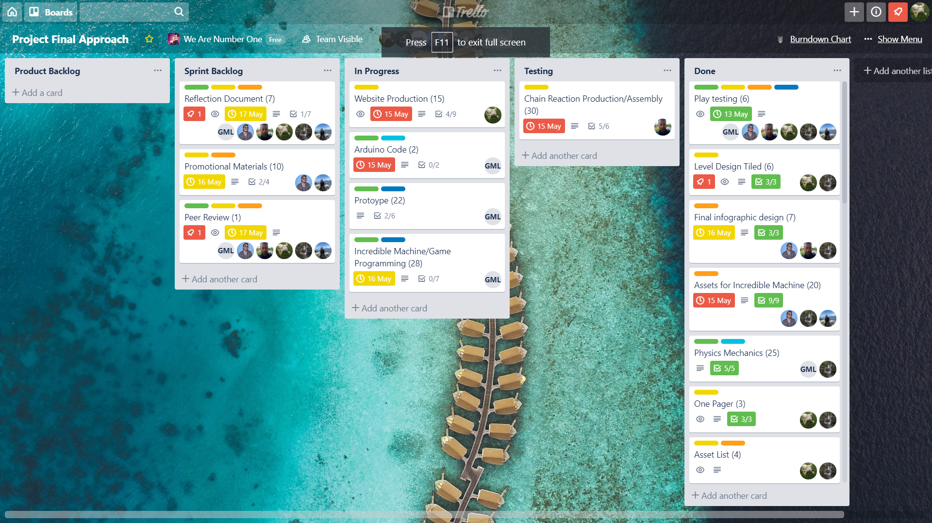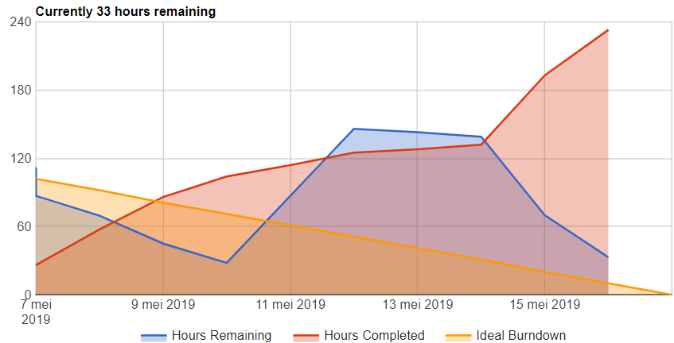

Trello explanation:

Here are our Trello board and burndown chart, as you can see the burndown chart is pretty steady until about the 15th of may where we finished a lot of story points but we’re pretty happy with how the flow of work went over the two weeks. Most of the finished story points on the 15th of may had been worked on before, but the 15th of may had a lot of finishing up work.

On the Trello there’s roles; Artist, Designer, Programmer and for the programming tasks it’s split up into engine development and gameplay programming. Each task has a role and programming ones have a role and a description. Each task has a user story and a check list which needs to be worked through and when those are completed those are the grounds of completion. Each task also has one or more people on it, depending on who’s supposed to work on it. When it goes to testing, the tester also puts their name on it so that when something is wrong there is full accountability.

The Trello structure goes as follows: Product backlog, Sprint backlog, In Progress, Testing, done.  
Everything for the project is in the product backlog. Things that are to be done in the current sprint go to the sprint backlog. When someone is currently working on it, it goes to in progress. Then when the checklist is complete it goes to testing. Once it is approved by the tester it goes to done. At the end of the day all tasks that are in progress should be moved back to the sprint backlog and story points spent should be logged on the burndown chart.

# Individual Work

## Individual Work Humam: Sound Designer/General Artist

I spent most of my time creating an auditory experience so it enhances the feel of the project by having music and audio effects that are in tandem with the visuals. There are sound effects that will play simultaneously with the chain reaction. I have also made the initial sketches of the character and most of the objects used in the digital part, so mostly all the 2D elements. I have also worked with Tamara and Rob to agree on the final sketch of the robot, so it was a collaboration of all artists. Other than that, I also created the logo of our installation, designed and created the info-graphic with all the content, alongside the poster itself. I made the infographic with circular layouts because circles appeal more to children and are more friendly. I have added a short description of each step of “making the robot” that is not too obvious nor too vague. The intention was that the info-graphic creates an image in the head of the person reading that prompts him to press the button and find out how the experience will play out.

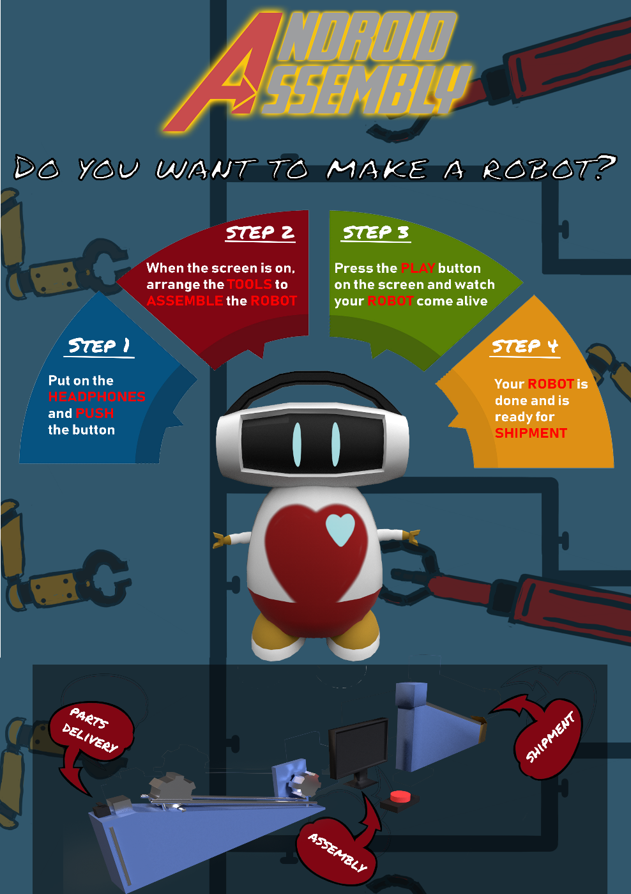

## Individual Work Tamara – 2D Artist

## Individual Work Rob – Scrum Master/ 3D Artist

My primary focus over the 2 weeks were 3d modelling (The main character and a render of the chain reaction) and Scrum Master/Project Management. I enjoy scrum a lot and I volunteered at the beginning to be scrum master, as you can see from the Trello section of this document my system is fairly standard but it works very effectively, there was no real crunch period in this project which in my opinion means the planning went very well. Some of the things that I think I could do better as a scrum master for the next project is put more pressure on people to log there used story points on the burndown chart to make that more accurate.



My other role as an artist I also feel went quite well, at the start I focused on stuff like figuring out the general style of the game with Humam and Tamara, and then I made the mood board, which was a challenge as it had 4 different iterations before it was good enough. Then my primary focus was 3D modelling the main character which we intended to 3D print, I successfully modeled and textured the character however, I left it too late to prepare the model for print, which is a lesson I learned and will know in the future. I also was the primary tester for a lot of the user stories on this project because I had a very good overview of the tasks.

**Full list of things I did:**

Character Model

Incredible Machine Model

General Assistance

Project Management

Mood Board

Testing

## Individual Work Rick – Web/Game designer

Initially, my focus was mostly on the game design, the documents(such as the one pager) and the website. I made the PowerPoints as well. This, along with the initial website design covered my first week pretty nicely. By Monday most of the website was done with only content and some small style changes here and there based on feedback left. I covered and processed the playtest here as well and made a template for this document. I started concepting some basic level design as well as making the various illustrator files for the laser-cutting(such as the keychain or the cogs on our physical chain reaction). I did a few art odd-jobs as well, such as cutting out the limbs of the robot in photoshop. At this point(Wednesday, week 2) I was also asked to help with the wiring, as we’d done little to this point except breadboard a few buttons. We have two servo’s and two buttons and I tested and soldered them all(With a little help from Olivier when I had to go back to level design) and managed to get it all working. Lastly, I also finished up the level design.

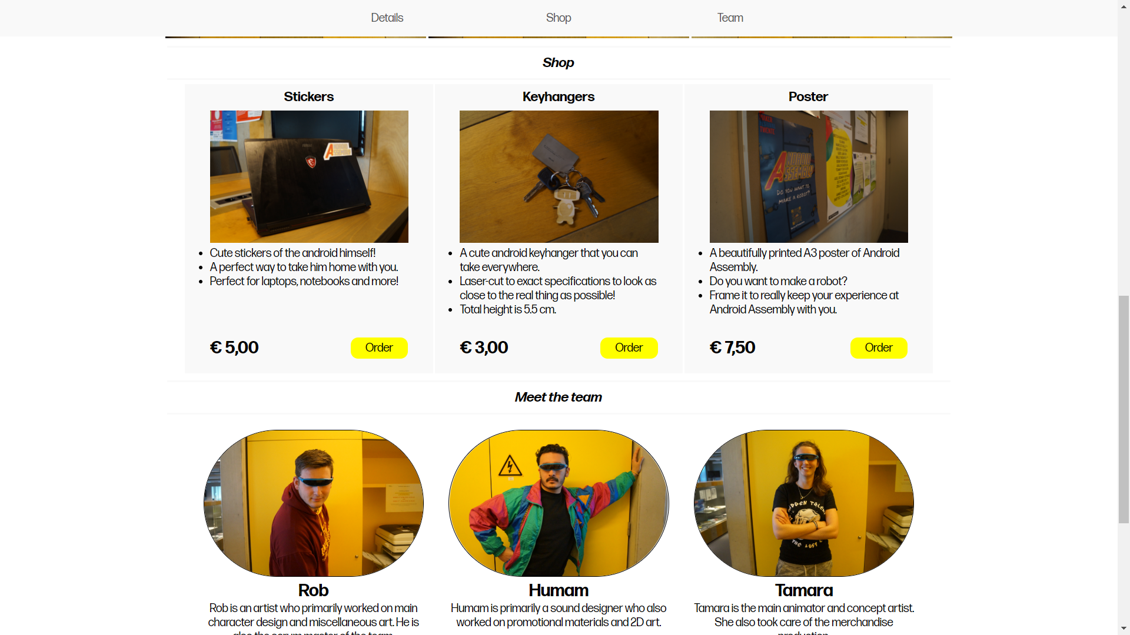

**Full list of things I did:**Game design document  
One pager  
Powerpoints  
Play Test + Processed Feedback  
Website  
Arduino Wiring  
Level Design

**ARDUINO PIC**

## Individual Work Olivier – Chain Reaction Designer

Post pictures/write a list of what you have done

## Individual Work Glyn - Programmer

Post pictures/write a list of what you have done

# Teamwork reflection

**What were the challenges/problems you faced as a team and how did you face them?**

During the feedback processing we had a conflict where the engineer disagreed with the decision to not implement a failure state. We had a vote and it was 5-1, so we discussed it with him and let him explain his reasoning to us after which we explained our reasoning to him to see if we could sway him. Holding a second vote afterwards led to a 6-0 result.

We also had a problem with deciding who from our team deserves the green card, we all felt everyone deserved it, so we resolved this by deciding who ever scored highest on the peer review would get it.

**What were the roles and were the roles respected?**

At the beginning we defined our roles very clearly before we even had a concept. Glyn would be our GXP programmer, Rick would be our web developer and Game Designer, Olivier would be our chain reaction designer and producer, Tamara would be our 2D animator, Rob would be our 3D artist and Scrum Master and Humam would be our 2D artist and Sound Designer.

We respected everyone’s roles by stating clearly at the start that everyone (within reason) could make a decision about their task, we also came with a positive attitude every day and gave constructive feedback instead of just saying something like “make it better”, we gave some feedback as to how to make it better.

**In what ways did you manage to help each other outside of your roles?**

The biggest way we helped each other outside of each other’s roles was voting on all big decisions made about the direction the project. This gave the team a democratic feel and made production go very smoothly. We also did a daily stand up where each person said what they did the previous day, what they plan to do today and raise any issues they have.

On the last day all artwork had been finished, so the artist were all hands on deck to help Olivier finish the production of the chain reaction.

**What would you do change for next project?**

Gameplay programming?